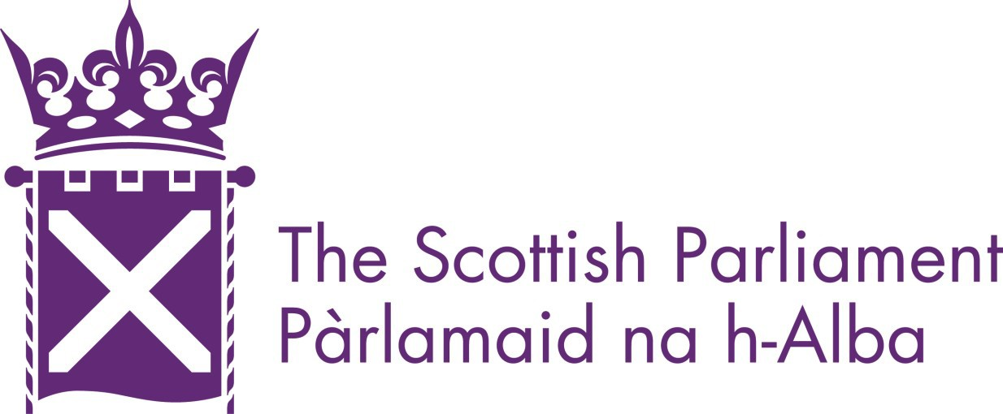

Managing for Excellence:
Our approach to performance management

Updated June 2021

The benefits that come from having a skilled, engaged and motivated workforce are critical to our success. Regular performance conversations and coaching has a positive impact on performance. It also improves engagement, wellbeing and resilience levels.

Our behaviours and individual objectives are linked to our strategic vision, aims and priorities. This helps us understand the purpose of our role and take responsibility for our own performance at work. It also complements good day-to-day management practice. It enables everyone to respond to the changing and challenging environment in which we’re operating. Our approach is underpinned using the following principles:
- quality conversations to drive high performance;
- conversations at regular intervals relevant to the role;
- proportionate, open and straightforward;
- colleagues are empowered to take ownership of their performance and development;
- managers using a coaching style by providing advice to stay on track toward objectives; and
- constructive feedback at an early stage to help improve performance in line with the Improving Performance Procedures

Who does what?
Leadership Group (LG) is accountable for setting the direction of the parliamentary service. This includes strategies, plans, resources, culture and values. This means using a collaborative approach, nurturing a culture where all colleagues feel empowered and safe to challenge and make a full contribution. It also means inspiring senior colleagues to deliver sustainable high-performance results in line with our purpose and values.
Office Heads and Team Leaders are responsible for developing a high-performance culture. This is done by setting standards of performance for the team and ensuring managers are applying these standards consistently. They also ensure team members work with peers in other offices to encourage collaboration for shared goals. This helps to review resources, plans and priorities and
take positive steps to build and sustain resilience.
Managers play a crucial role in driving successful results and keeping team members informed about their progress toward the achievement of objectives. Managers also encourage colleagues to act in the manner consistent with our values and provide feedback and/or take action when standards are not met.
Colleagues are at the heart of the process. Setting objectives with managers, identifying development needs and taking responsibility for delivering these. They are also responsible for providing feedback to others to ensure our standards are maintained and escalate issues of concern in a timely and constructive manner.
The People and Culture Office supports this by embedding our values into the people management practices. They also align learning and development activities to shared priorities and goals.
This tool clarifies our roles and responsibilities, making sure that nothing falls through the cracks.

How do our roles link to the Strategic Plan?

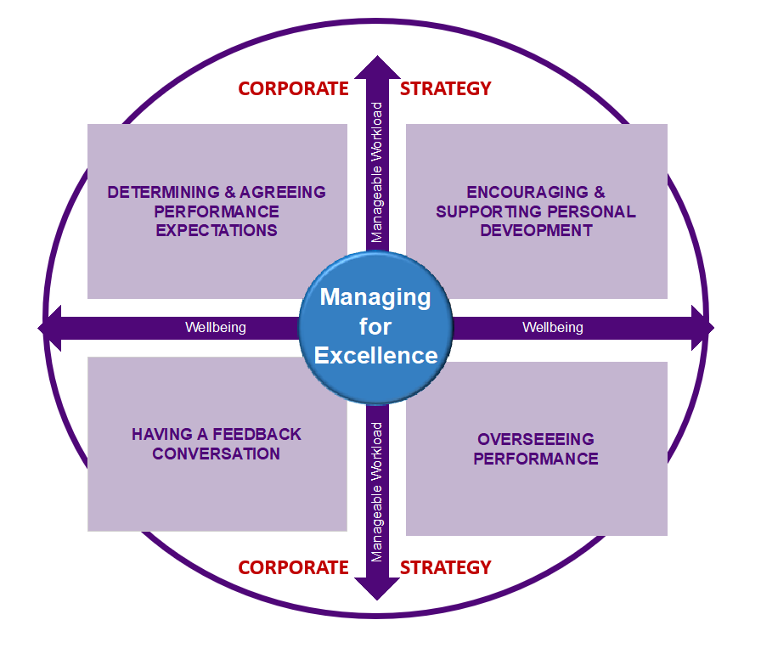

The main aspects of performance management focus on knowing what we’re here to achieve and
translating this into day-to-day activities. Our strategic plan identifies the high-level priorities we work towards, together with our intended impact. This, in turn, shapes our delivery plan and office plan, which sets out the specific results and improvements we seek to make through our work, the activities we carry out to achieve these and how they’ll be measured. This supports a culture of
continuous improvement and feedback and is reviewed and updated throughout the year.

This helps us to focus on what’s important and understand how service delivery is progressing. Most crucially, it enables us to make effective well-informed and timely decisions which focus on our
strategic goals. This means that there’s an understandable and well-communicated link between the achievement of the Parliament’s vision and individual objectives.

It fits together as follows:

Strategic Plan
This is a plan for the Parliament as a whole. Our overarching goal is to ensure the Parliament is at the forefront of the political debate and remains relevant to the people of Scotland.

Delivery Plan
This translates the ambitions of our strategy into reality. It reflects the ongoing work to ‘Run the Parliament’ which accounts for most of our day-to-day activities, as well as initiatives to ‘Improve the Parliament’ and risk management measures.

Office Plan
Each office has a clear line of sight from their office plan to the strategic plan. A key emphasis here is to support and encourage meaningful conversations and collaborative working between teams.
This approach is also embedded into our approach to performance management.

Individual Plan
This is where we set out our objectives and priorities of our roles and the behaviours expected to successfully achieve them. Here, we reflect on our office plan by considering what goals we can work towards that’ll contribute to the delivery of the plan for the year ahead. We also consider what personal development is needed to achieve these and timescales for delivering these.

Performance Reporting
This is where we encourage high performance and track our performance. We consider this to be
the most important aspect of our approach. It ensures our services are fit for purpose and that risks are managed. We use a quarterly red, amber green status (RAG) mechanism to measure and monitor the successful achievement of our plans.

Continuous Improvement and Feedback
At an individual level, we seek constructive feedback on how we’re performing through our regular conversations with our managers. We do this to identify barriers to high performance, such as the quality of objectives, workload, wellbeing and areas of training and support. This also helps to address performance issues before they potentially become more serious.

How does the approach link to the values?

Our performance is measured not just on what’s been achieved but also how we’ve achieved it. Both parts are important and effective performance means doing each part equally well. Together, they give us an opportunity for learning and exploring what’s been achieved because of our
contributions and behaviours. Our values and behaviours framework captures the standards expected of us in our everyday work. This provides an important checkpoint for colleagues to reflect upon, to exhibit behaviours that are consistent and demonstrate a commitment to the values of the parliamentary service.

What are the benefits?

Defining performance in this way ensures we’re better able to:

- support or advance our vision, goals, priorities and values;
- collaborate with colleagues with greater transparency and mutual understanding;
- encourage two-way feedback to celebrate success;
- identify areas of personal growth to continually improve and learn;
- reflect on our progress by measuring and assessing whether our actions and behaviours have had the desired impact;
- remain resilient when barriers arise; and
- address and discuss underperformance issues early and at the point of need.

What guidance is available to define office/team objectives?

We know that offices perform and deliver diverse functions and services and have different planning needs and requirements. Many offices routinely provide ‘Run the Parliament’ services and activities and others also deliver projects and programmes that ‘Improve the Parliament’.

The key to effectively delivering all of these is to support and encourage meaningful conversations and collaborative working. This is threaded through all our planning processes. Have a look at the
Office Planning Guidance to see how it all connects.

How do we keep our priorities on track?

Our quarterly reporting mechanism helps to track of our performance against our aims and priorities. We use a red, amber, green status (RAG) framework to measure our combined efforts and to keep us on track:

RED | There are significant issues impacting the achievement of the objectives and goals. To achieve delivery changes must be made to timing, budget, staffing levels, capability levels and/or scope of work.
AMBER | There are issues or risks which must be addressed. However, successful delivery is achievable without major impacts to target dates, budget, other members of the team  and/or scope.
GREEN | Work is meeting agreed standards or is proceeding to plan. All known risks are being  managed.

We all support the successful outcome of the Delivery Plan through our efforts to deliver ‘Run the Parliament’ and ‘Improve the Parliament’ objectives. Some colleagues use this mechanism to track their individual performance while others use Service Level Agreements (SLAs) or Key Performance Indicators (KPIs) to track theirs.

Our office plans help to determine the appropriate mechanism. Whatever the case, managers will set and monitor the standards of performance and keep their team members informed about their progress.

Remember, our performance is assessed not just on what’s been achieved but also how we’ve
achieved it. Making time for frequent feedback is important, so there’s alignment around shared values. Good feedback is what’ll help us improve our performance and enhance our skills. That’s why we should all request and accept constructive feedback on our work on a regular basis. Managers should create an environment of trust that makes it okay to share feedback - where it’s viewed as an opportunity for growth.

We talk about managers using a coaching style – what does this mean?

This is about providing colleagues with the space to think and reflect about situations from different perspectives and to tap into the skills and experiences they have. It also helps to:

- identify and solve problems
- make decisions and set goals
- gain clarity in our thinking and commitment to our goals
- identify barriers that could be holding us back from achieving our goals and
- build better relationships with our colleagues

This will, in turn, enhance our personal effectiveness, along with our teams. When approached in
this way, it becomes self-directed learning. Have a look at the OSCAR model as a guide.

We talk about wellbeing and resilience – what does this mean?

Good health and wellbeing is central to our culture and underpins our approach to performance management. Our approach encourages conversations about workload pressures and our general wellbeing by capturing what’s going well and by identifying any issues that need to be addressed.

Have a look at the wellbeing guidance which has been developed to provide managers and staff with a practical guide during Covid-19 to ensure that everyone feels supported in doing their job. It aims to identify any risks to physical and mental health, safety and wellbeing and to make sure we as an organisation respond appropriately to these. We understand that the situation is placing extraordinary demands on many colleagues - please talk to your manager or the People and Culture Office for support.

What’s the process for performance management?

The process is simple and is designed to provide continuous support and learning. This is driven by dates captured in our office planning arrangements from June to May. We should all follow this process to ensure consistency of application and outcome across the parliamentary service.

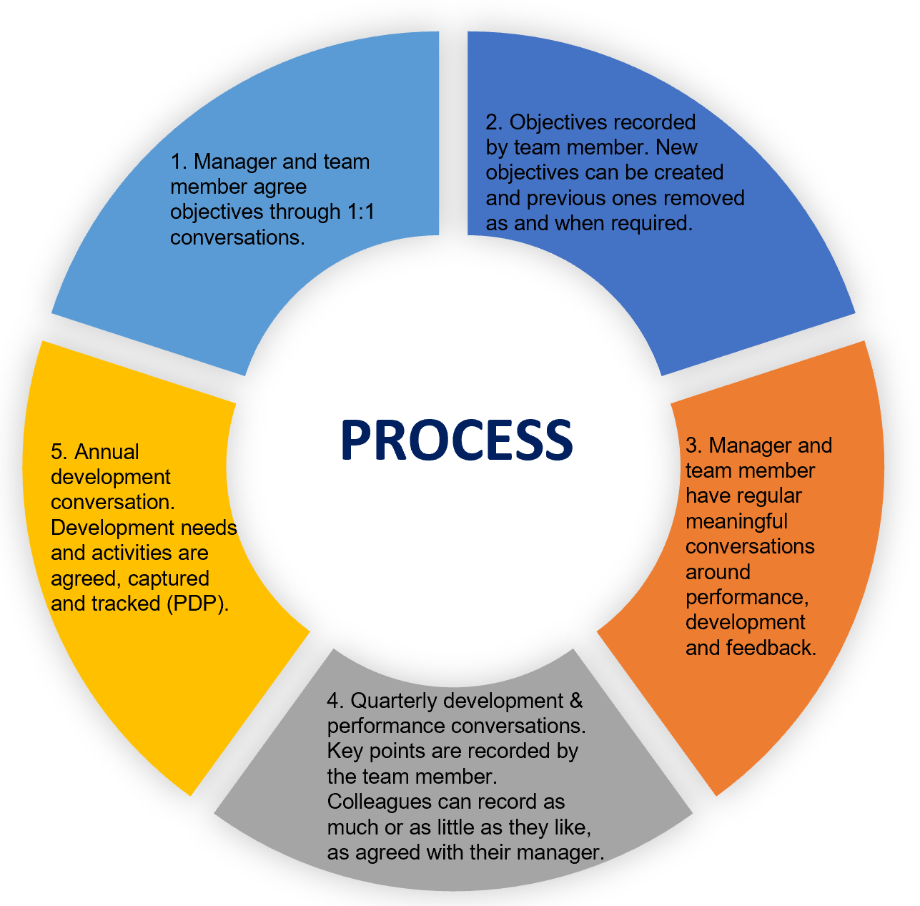

How should objectives be set?

Objectives detail the key priorities of our roles both now and in the future. As all offices work differently, the number of objectives set will reflect the activities captured in the office plan.
The most important thing is to ensure workload is manageable, so it’s important to keep our workload activities under review throughout the year. When agreeing objectives, colleagues can
sense check each one using the SMART acronym. The following questions might also be helpful:

- How does the role support the delivery of the office plan?
- What does success look like? Can it be measured (e.g. are there agreed Service Level Agreements (SLAs) or dates captured in a project plan or Delivery Plan)?
- Who or what might impact on the successful delivery of the objective?
- Are there any resource/budget requirements and if this changes how will this impact on
the successful delivery of the objective?
- What training and development is needed to successfully deliver the objectives?

PDP - How do we capture our development needs?

The pressure of a busy schedule and tight resources can cause colleagues to lose sight of their career and development goals. To remain focused, we should all use a well-written, structured personal development plan (PDP). Colleagues may find the following questions useful:

- What do I want to get out of my work?
- Which new skills, or improved skills, would enhance my work performance?
- What skills or experience would allow me to feel more confident at work?
- What have I achieved in my career so far?
- What would I like to be doing in 12-18 months’ time?
- What are my strengths and which parts of my role would I like to improve?
- What’s preventing me developing as I would like?
- How do I learn best?

We should have at least one annual PDP conversation. Remember, most of our learning will happen on the job and from engaging with others, internally and externally. You can book some time with People and Culture colleagues to discuss your needs.

Are we expected to write down our objectives and development plans?

Yes. We must all know what’s expected of us and our plans help us to:

- agree our individual objectives and goals with our managers;
- seek ongoing feedback;
- take responsibility for developing new skills; and
- address any potential performance issues before they become more serious.

Recording this information helps us to keep track of what’s been agreed. As a minimum, we expect colleagues to share their PDPs a with their manager to set and track objectives.

How do we do this?

The admin side of our approach is flexible and recognises that offices and teams work differently We have produced forms to capture our objectives, development and wellbeing activities, which are saved in career folders. We’ll continue to review this, and our process in general, to ensure it supports our outcome. That is, to ensure we have a high performing, resilient and engaged workforce. The key point here is that conversations are taking place.

How often should we meet?

As well as regular 1:1s to help resolve specific issue or challenges, you should meet on a quarterly basis. Managers should be proactive in supporting their team members who may be struggling with a performance issue. Meetings can be extended to have more time to reflect and discuss important topics, such as reviewing objectives and budgets in line with the agreed timescales. This helps us to focus our efforts on the activities that help ‘Run the Parliament’, as well as initiatives to ‘Improve the Parliament’. The most important thing is that we all feel supported in our roles.

Is there a recommended structure for holding conversations?
Yes. We have a toolkit for staff which includes a worked up an example for managers to help structure our conversations. Colleagues can also use the top tips on getting the most out of your performance management.

Is there a separate process to support colleagues who need additional support to improve their performance?
Yes. The Improving Performance policy and procedures are in place to support colleagues to meet the required standards of performance and behaviour. Managers should always raise issues informally with their team members during the regular conversations in the first instance. This might include exploring why a colleague’s performance has not met expectations, clarifying goals and discussing any support they need for their performance to improve. We know that dealing with underperformance can be challenging for managers and colleagues alike, but it does need to be addressed and resolved early. The longer that this continues, the more difficult a satisfactory resolution becomes. If you’re a manager, contact the People and Culture Office to discuss next steps.

How are we doing?

In the spirit of our approach to performance management we welcome your feedback. Your answers to these questions will help us assess the usability of this guidance document:

- I understand how my objectives support the delivery of the strategic and office plans
- I receive ongoing feedback that helps my performance
- I am confident that my manager considers my welfare and workload in setting my objectives
- I feel my contribution to the team is valued
- My manager is approachable, and I can be open and honest about issues that are
concerning me
- I understand what’s expected of me and the process enables this
- I have the skills and confidence to perform my role, as defined through this process
- I would welcome the opportunity to discuss the process in more detail with the People and Culture Office

Managing for Excellence:

Our approach to performance management

For further information contact: HumanResources@parliament.scot 0131 348 6500

